**Program-8:** To **Run the Applet** Program Follow the below Steps:

**Note:**

Applets have been **deprecated** and **removed** from modern versions of Java (since Java 9). Therefore, the usual process of creating and running applets may no longer work with the latest JDKs (like JDK 11 or later).

1. **Install JDK 8:**

<https://www.oracle.com/in/java/technologies/javase/javase8-archive-downloads.html>.

1. **Add JDK-8 to NetBeans IDE (if not already added):**

* Open NetBeans IDE.
* Go to Tools > Java Platforms.
* In the Java Platforms dialog box, click Add Platform.
* Navigate to the location where JDK 8 is installed (e.g., C:\Program Files\Java\jdk1.8.x_x).
* Select the JDK 8 folder and click Next.
* Follow the prompts to add JDK 8 to NetBeans.

1. **Create Applet Program:**

* Open NetBeans IDE
* Select File -> New Project and Then the below window will Come,

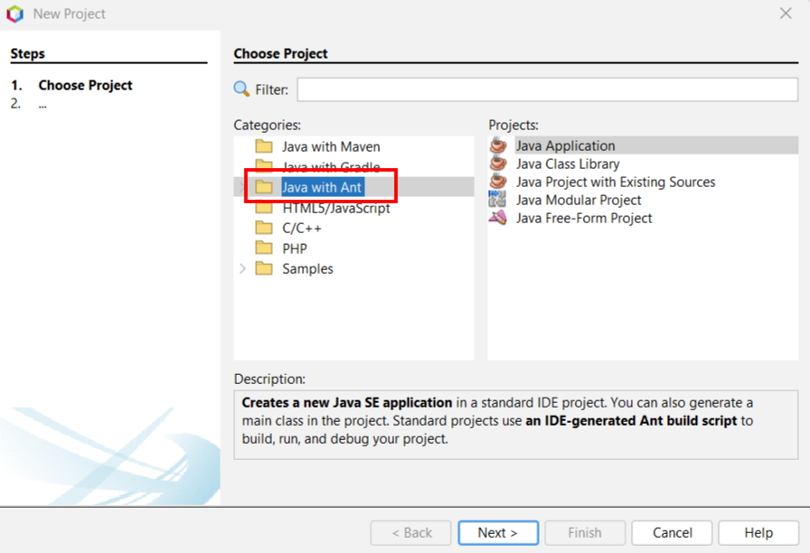

* Now Select Java with Ant -> Java Application -> Next.
* A new window will Open as below, Give the Name and Uncheck the Create Main Class Checkbox, Finish.

In the Left Side of the Window Open Your Project Folder

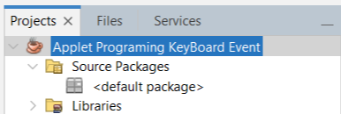

* Now right Click on **the <default package ->** **New** -> **Other** Applet File as below:

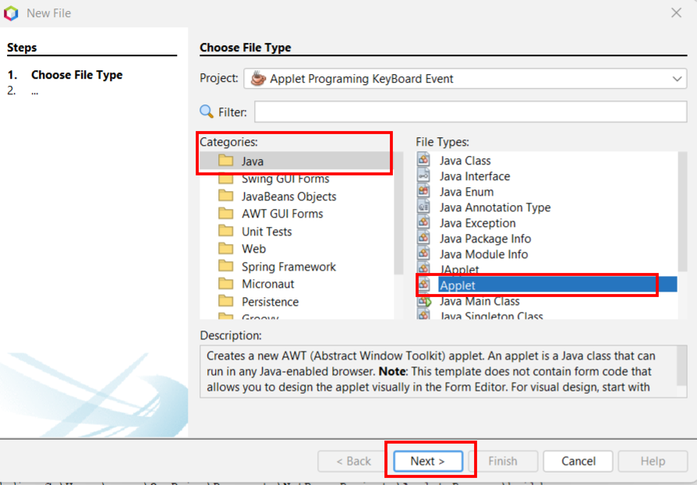

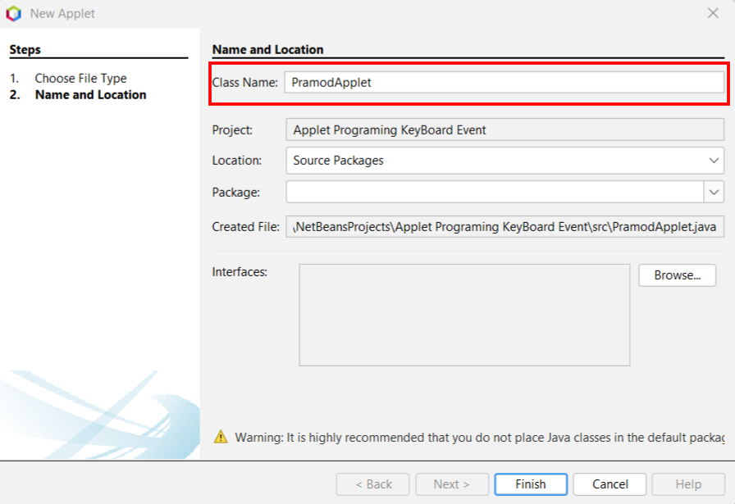

**Write the Below Code inside the Applet File:**

**How To RUN:** Using **AppletViewer** **Tool**

The Traditional or Legacy applets are embedded in HTML page, as below, But Unfortunately, modern browsers **don't support applets** anymore. To run your applet, you’ll need to use the appletviewer tool, which is included in JDK 8.

So, Right Click on the Source File and Select **Run File,** This will open the **AppletViewer** **Tool**.

How to Embed the Applet Code in HTML File: TO do so use the below,

**Create a new HTML file in the source package:**

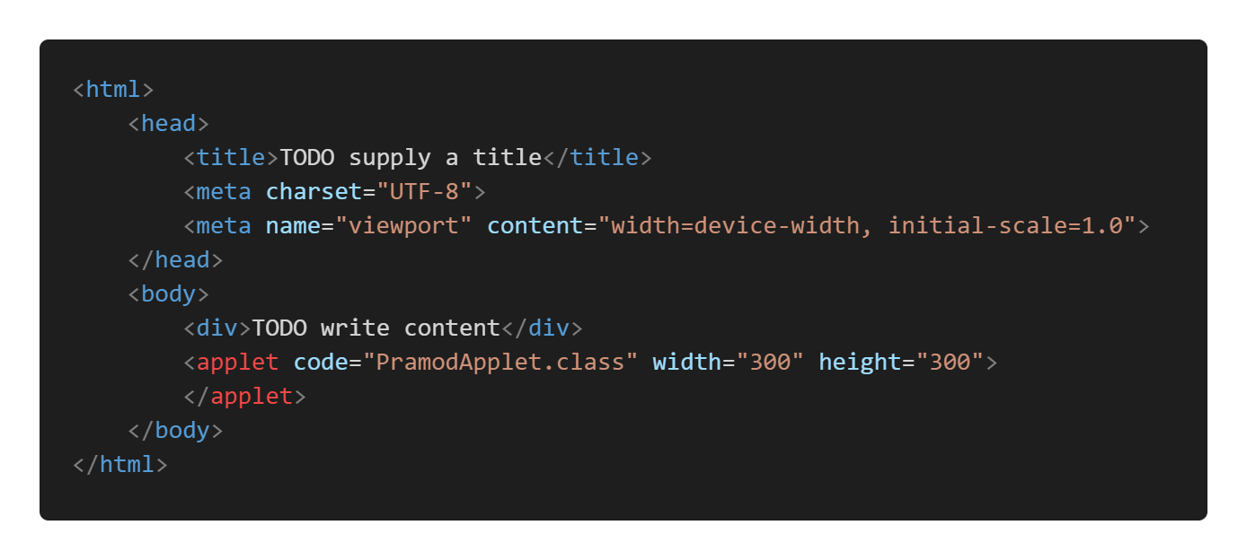

1. **Set JDK 8 as the Default Platform for Your Project:**

* In the Projects window, **right-click** on your project.
* Select **Properties** from the context menu.
* In the Project Properties dialog, go to **Libraries** on the left.
* Under the **Java Platform** section, you'll see a dropdown menu for selecting the **JDK version**.
* Select **JDK 1.8** (default) from the list. If it is not available, select JDK 1.8 (the one you just added).
* Click OK.

**4. Verify Java Version in Project:**

* To verify that your project is using JDK 8, go to **Files**-**View** in NetBeans.
* Open the **nbproject** folder inside your project.
* Open the **project.properties** file.
* Ensure the following entries point to 1.8
  + javac.source=1.8
  + javac.target=1.8

**Program-8:** Write a Java **applet program**, which handles **keyboard event**